*Florida International University*

*School of Computing and Information Sciences*

Software Engineering Focus

Feature Document

User Story ID #777 Web Application for Implemented Devices

**Name:** Bernardo Pla

**Team Member(s):** Pachev Joseph, Hamilton Chevez, Daniel Khawand, Daniel Rivero

**Project:** WEBVR 1.0

**Product Owner(s)**: Francisco Ortega

**Mentor(s)**: Francisco Ortega

**Instructor**: Masoud Sadjadi

**User Story Name: #777** **Web Application for Implemented Devices**

* Description: As a developer, I want to create a Web Application so that a graphical output of using the Rust library can be displayed

Acceptance Criteria

* Web Application can successfully communicate with the Rust device library
* Application can track updates using the Rust library
* Demo approved by product owner

**Use Case**

* Name: Web Application for Rust Library
* Actor: User, Web Application, Rust Library
* Preconditions:
  + Web Application can be reached via localhost:8080.
  + User has a mouse device connected to the computer
* Description <Flow of events>:
  + User navigates to localhost:8080
  + Web Application loads the Default.aspx page
  + User clicks their desired demo, in this case, the Mouse Demo button
  + User interacts with demo
    - Interactions are handled by the communication between the application and the backend rust library
  + User can exit either by clicking the “Back” button or exiting the browser

**Use Case Diagram <**you can use draw.io**>**

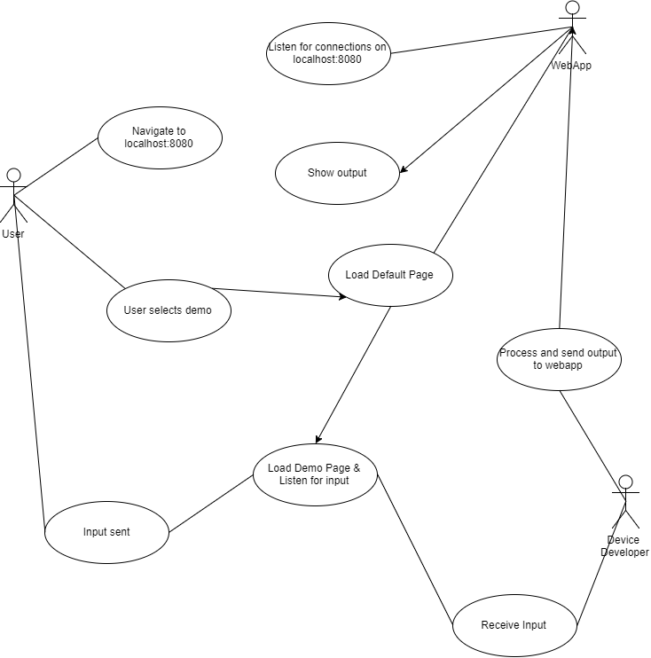

**Fig-1**: Use Case Diagram for User Story ID #777. This shows the interaction between the WebApp, User, and Device Developer.

**Sequence Diagram**

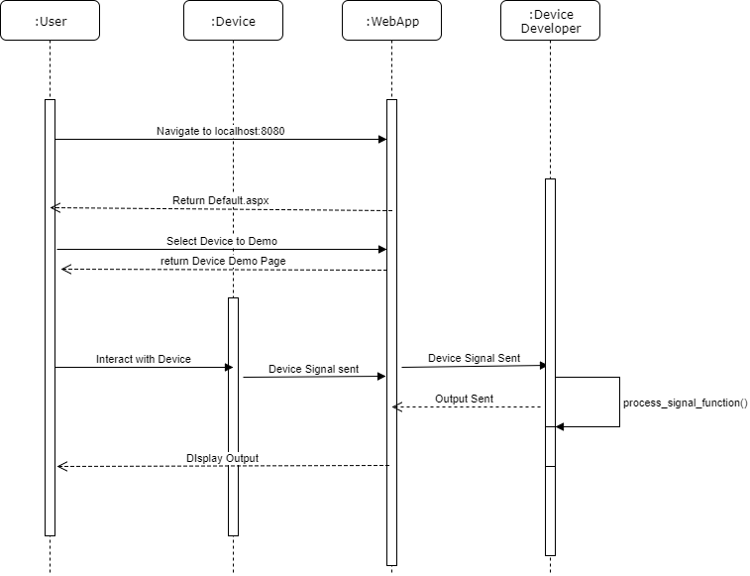  
**Fig-2**: Sequence Diagram for User Story ID #777: Displays the sequence of events that take place during an interaction with the Web Application

**Class Diagram**

**Unit Test**

* Test case ID: SysTest001-WebApplication-and-Rust-Library-Interaction
* Description/Summary of Test: In this test, the web application is launched and hosted at localhost:8080. The user clicks the “Mouse Demo” button. The Web Application directs them to the mouse demo page. The user interacts by clicking within the window. These interactions are recorded and processed by communication between the rust library and the web application
* Pre-condition:
  + User is already on homepage of localhost:8080
  + Mouse is connected to user’s machine
* Expected Results: The user can successfully interact with the page. The responses from the page are handled by function calls to the rust library.
* Actual Result: A communication error was present and the web application and rust library were unable to pass functions between them. This is caused by difficulties in created shared object files of the rust library and adding them as packages for the web application. When an event was handled by the rust library, the web application would stop functioning because it could not locate the shared object files.
* Status (Fail/Pass): Fail

**Integration Test**

**Visual User Guide** 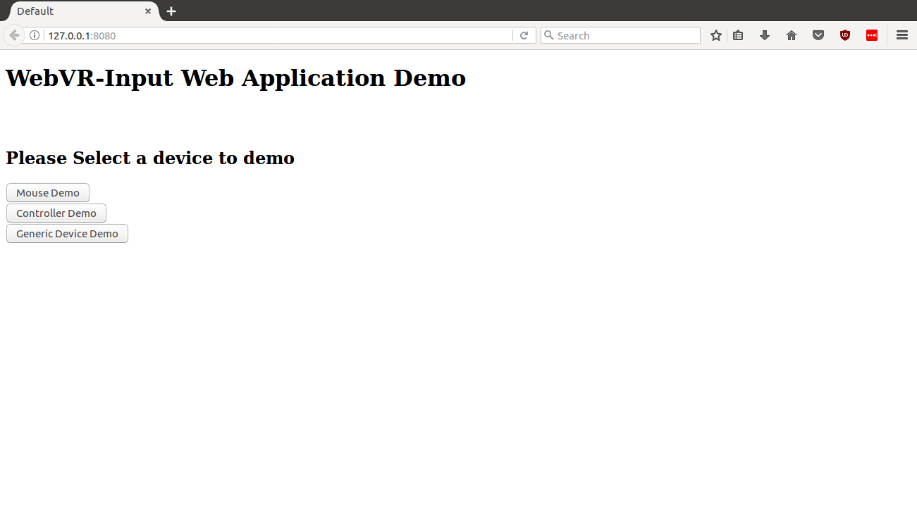

**Fig-3**: Web Application Home Page - This page was the default page when localhost:8080 was called. It is a simple page with buttons that direct the user to demo pages in which they can interact with the device.

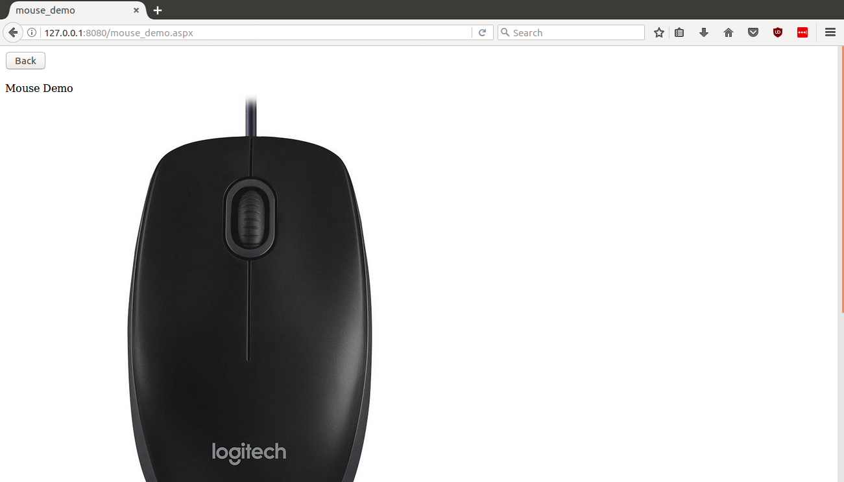

**Fig-4**: Mouse Demo Page - When the user clicks the “Mouse Demo” button, they are taken to this page to see their interactions being recorded and processed by the rust library.